**NEPAL ENGINEERING COLLEGE**

(Affiliated To POKHARA UNIVERSITY)

**Changunarayan, Bhaktapur**



**Report on:**

**LPG Gas Leakage Detection Alert and Monitoring system**

**SUBMITTED BY:**

Aashish Timalsina (019-401)

Bikesh Raj Bhatta (019-421)

**SUBMITTED TO:**

Department of Electronics and Communication Engineering

Nepal Engineering College

Bhaktapur, Nepal

# ACKNOWLEDGEMET

It is appropriate for us to start our humble vote of thanks to Asst.prof Vijay Shrestha &Asst.prof Sachin Shrestha for providing us so much of knowledge and letting us to do a project with new idea and thoughts. We would also like to thank CTRC.nec (Computer Technology and Robotonix Club) for providing us platform **as** well as helping us in different mode of our project.

We could not remain without thanking the staff member of Electronic and communication Department for providing and promising to provide us the required facilities and support towards the completion of the project.

Last but not the least; I would like to express our heartfelt gratitude to mine friend and well-wishers, inside and outside of our college for their help, co-operation and solutions to problem during the course of the project.

# ABSTRACT

The explosion due to gas leakage has become a serious problem in our country's daily activities. Now the world is evolving with technology, so it is necessary to use technology, if possible, in every case. LPG gas to resolve the accident occurred we can prevent it through technology. The system is based on a microcontroller, which uses gas sensors as well as Thing speak Interface, display and buzzer. It is designed for LPG Gas Leakage Monitoring and Alert System using ESP-32 with MQ6 sensor. The uses of the ESP-32 microcontroller provide a suitable platform for implementing an embedded control system and it is possible to modify it to meet our future requirements easily and quickly.

The LPG gas leakage in a domestic, work place, also, stored gases container gas which exhibits ideal characteristic is use. For that sake, an alarm unit is used to vibrate an alarm which is buzzer. Buzzer gives an audible sign of the presence of LPG volume. The sensors are widely used to detect essence of propane, iso-butane, LPG and even smoke. ESP-32 is used in the project; low signals are overlooked by the ESP-32 and gas leakage is been noticed by the buzzer via sms system. The ESP-32 turns on the LCD and buzzer. It even turns on the thing speak after that, it continues to send alert messages specifically mentioned in the program of the source code for alerting danger to the people

The use of LPG gas in car and home is very risky. The LPG gas cylinders used at home and elsewhere are the same condition, which is mainly due to LPG gas leakage accidents. For the protection and security of LPG gas explosion problem, we design the IOT based system to prevent home and vehicle accidents.

Table of Contents

ACKNOWLEDGEMENT ii

ABSTRACT iii

1.INTRODUCTION………………………………………………………………………………1

1.1 Background………………………………………………………………………………...1

1.2 Objectivesand Scope……………………………………………………………………….1

1.3 Application…………………………………………………………………….….………..1

1.4 Overview of Proposal 2

2 LITERATURE REVIEW 3

3 METHODOLOGY 4

3.1 Basic Block Diagram 4

3.2 Circuit Digram 5

3.2 Algorithm 6

4  HARDWARE AND SOFTWARE 7

5 EXPECTED OUTPUT….............................................................................................................8

6 COST ESTIMATION…………………………………………………………………………..8

7 FEASIBILITY ANALYSIS……………………………………………………………………9

7.1 Future Scope………………………………………………………………………….......10

7.2 Adavantage………………………………………………………………………….........11

CONCLUSION…………………………………………………………………………………..12

REFERENCES...………………………………………………………………………………..13

APPENDIX…..………………………………………………………………………………….14

# 1. INTRODUCTION

## 1.1 Background

The LPG or propane which is flammable mixture of hydrocarbon gases used as fuel in

many applications like homes, hostels, industries, automobiles, vehicles because of its

desirable properties which include high calorific value, which produce the less smoke,

produces less soot, and does not cause much harm to the environment.

The LPG or propane which is flammable mixture of hydrocarbon gases used as fuel in

many applications like homes, hostels, industries, automobiles, vehicles because of its

desirable properties which include high calorific value, which produce the less smoke,

produces less soot, and does not cause much harm to the environment.

The LPG or propane which is flammable mixture of hydrocarbon gases used as fuel in

many applications like homes, hostels, industries, automobiles, vehicles because of its

desirable properties which include high calorific value, which produce the less smoke,

produces less soot, and does not cause much harm to the environment.

The LPG or propane which is flammable mixture of hydrocarbon gases used as fuel in

many applications like homes, hostels, industries, automobiles, vehicles because of its

desirable properties which include high calorific value, which produce the less smoke,

produces less soot, and does not cause much harm to the environment.

The LPG or propane which is flammable mixture of hydrocarbon gases used as fuel in

many applications like homes, hostels, industries, automobiles, vehicles because of its

desirable properties which include high calorific value, which produce the less smoke,

produces less soot, and does not cause much harm to the environment.

The LPG or propane which is flammable mixture of hydrocarbon gases used as fuel in

many applications like homes, hostels, industries, automobiles, vehicles because of its

desirable properties which include high calorific value, which produce the less smoke,

produces less soot, and does not cause much harm to the environment.

The LPG or propane which is flammable mixture of hydrocarbon gases used as fuel in

many applications like homes, hostels, industries, automobiles, vehicles because of its

desirable properties which include high calorific value, which produce the less smoke,

produces less soot, and does not cause much harm to the environment.

The LPG or propane which is flammable mixture of hydrocarbon gases used as fuel in

many applications like homes, hostels, industries, automobiles, vehicles because of its

desirable properties which include high calorific value, which produce the less smoke,

produces less soot, and does not cause much harm to the environment.

The LPG or propane which is flammable mixture of hydrocarbon gases used as fuel in

many applications like homes, hostels, industries, automobiles, vehicles because of its

desirable properties which include high calorific value, which produce the less smoke,

produces less soot, and does not cause much harm to the environment.

The LPG or propane which is flammable mixture of hydrocarbon gases used as fuel in

many applications like homes, hostels, industries, automobiles, vehicles because of its

desirable properties which include high calorific value, which produce the less smoke,

produces less soot, and does not cause much harm to the environment.

The LPG or propane which is flammable mixture of hydrocarbon gases used as fuel in

many applications like homes, hostels, industries, automobiles, vehicles because of its

desirable properties which include high calorific value, which produce the less smoke,

produces less soot, and does not cause much harm to the environment.

The LPG or propane which is flammable mixture of hydrocarbon gases used as fuel in

many applications like homes, hostels, industries, automobiles, vehicles because of its

desirable properties which include high calorific value, which produce the less smoke,

produces less soot, and does not cause much harm to the environment.

The LPG or propane which is flammable mixture of hydrocarbon gases used as fuel in

many applications like homes, hostels, industries, automobiles, vehicles because of its

desirable properties which include high calorific value, which produce the less smoke,

produces less soot, and does not cause much harm to the environment.

The LPG or propane which is flammable mixture of hydrocarbon gases used as fuel in

many applications like homes, hostels, industries, automobiles, vehicles because of its

desirable properties which include high calorific value, which produce the less smoke,

produces less soot, and does not cause much harm to the environment.

The LPG or propane which is flammable mixture of hydrocarbon gases used as fuel in

many applications like homes, hostels, industries, automobiles, vehicles because of its

desirable properties which include high calorific value, which produce the less smoke,

produces less soot, and does not cause much harm to the environment.

The LPG or propane which is flammable mixture of hydrocarbon gases used as fuel in

many applications like homes, hostels, industries, automobiles, vehicles because of its

desirable properties which include high calorific value, which produce the less smoke,

produces less soot, and does not cause much harm to the environment.

The LPG or propane which is flammable mixture of hydrocarbon gases used as fuel in

many applications like homes, hostels, industries, automobiles, vehicles because of its

desirable properties which include high calorific value, which produce the less smoke,

produces less soot, and does not cause much harm to the environment.

The LPG or propane which is flammable mixture of hydrocarbon gases used as fuel in

many applications like homes, hostels, industries, automobiles, vehicles because of its

desirable properties which include high calorific value, which produce the less smoke,

produces less soot, and does not cause much harm to the environment.

The LPG or propane which is flammable mixture of hydrocarbon gases used as fuel in

many applications like homes, hostels, industries, automobiles, vehicles because of its

desirable properties which include high calorific value, which produce the less smoke,

produces less soot, and does not cause much harm to the environment.

Gas leak detection is a process of identifying (propane, butane) gases in the surrounding environment by the use of sensors, thereby paving a way to prevent further repercussions. Liquefied Petroleum Gas is commonly known as LPG. It is used in many applications in the industrial sector namely in space and process-heating, powering industrial ovens, production of food, furnaces, production of packing material as well as in powering forklift trucks in warehouses

In the proposed system, we employ a gas sensor to keep a check on the concentration of LPG in the surrounding. The user and his neighbors are audibly notified about the leakage by buzzer and a warning message is sent to the user. To reduce risk to human life

## 1.2 Objectives and scope

The major objective of this project is to design & develop a system to detect the leakage of LPG gas. The specific objectives are

* To use MQ6 detect the leakage of LPG gas in a closed environment.
* To inform the user about the leakage of gas through BUZZER via Email.
* To activate the alarm unit to inform neighbors about the gas leakage.
* Monitoring gas leakage through thing speak IOT platform.

## 1.3 Applications

* Protection from any gas leakage Home, Office, car and other application.
* For safety from gases leakage in heating gas fired application like boilers, domestic water heater
* Large industries which use gas as their production
* For safety from leakage in cooking gas fired appliances like over stoves etc.

## 1.4 Overview of proposal

In gas leakage detection process, any gas leakage is checked by gas sensor (MQ-6) which is interfaced with ESP-32. When leakage is detected, buzzer will we activated and sending the alert message through Email using SMTP protocol until turn off the gas regulator-switch at same time it informs the user sending Email and monitoring through thing-speak interface sending via messages , turning on the buzzer.

# 2. LITERATURE REVIEW

Ch. Manohar Raju and N. Sushma Rani, 2008[1]; they introduce an android based automatic gas detection and indication robot. They proposed prototype depicts a mini mobile robot which is capable to detect gas leakage in hazardous places. Whenever there is an occurrence of gas leakage in a particular place the robot immediately read and sends the data to android mobile through wireless communication like Bluetooth. We develop an android application for android based smart phones which can receive data from robot directly through Bluetooth. The application warns with an indication whenever there is an occurrence of gas leakage and we can also control the robot movements via Bluetooth by using text commands as well as voice commands. The previous mobile robots are based on heterogeneous technologies like GSM, GPS, internet based etc., but the main disadvantage of those prototypes were the absence of communication in particular areas.

Pal-Stefan Murvaya, Ioan Sileaa, 2008[2]; they told in their survey on gas leak detection and localization techniques various ways to detect the gas leakage. They introduce some old or new technique to detect the gas. The proposed techniques in this paper are nontechnical methods, hardware-based methods which to the user. Stepper motor IC (ULN 2003A) to drives the stepper motor attached it, as a result main power and gas supplies turn off. At the end, when the gas leakage is successfully stopped then with the help of reset button the whole system reached to the initial stage.

Humans cannot detect the presence of natural gases as fast as the sensor does. Thus, the gas sensing mechanism is hugely needed to give real-time monitoring of the gas system. As we know its leak may lead to a disaster. Here we have developed IOT primarily based LPG gas detector alarm. If gas outpouring happens, this technique detects it, raises an alert by droning the buzzer connected with the circuit. This technique is simple to create and anyone who has some information of physics and programming will build it.

**3. METHODOLOGY**

In this paper An MQ6 semiconductor sensor which has lowers conductivity in clean air. When the target combustible gas exists, the sensor conductivity increases along with the rising gas concentration. The MQ6 gas sensor has a high sensitivity to Propane, Butane and LPG, and response to Natural gas. The sensor could be used to detect different combustible gasses, especially Methane; it low-cost and is suitable for different applications. The MQ-6 can detect gas concentrations anywhere from 200 to 10,000 ppm

## 3.1. Basic Block Diagram

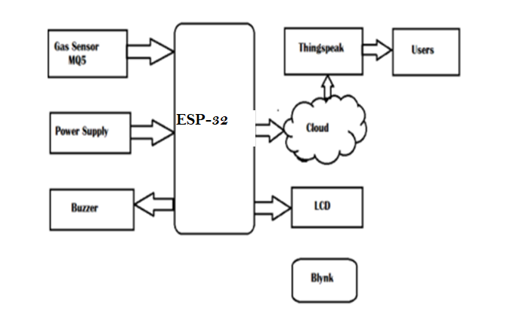

## 3.2. Circuit Digram

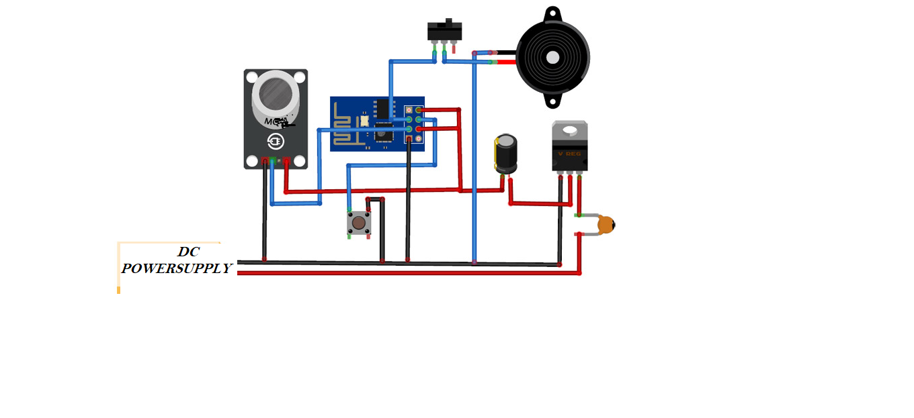

## 3.3. Algorithm

## Design of an IoT based Real Time Environment Monitoring System using Legacy Sensors

# 4. Hardware and software

## 4.1. LPG SENSOR (MQ-6)

It is the most popular **Analog Gas Sensor** used is MQ5 Gas Sensor. The MQ5 gas sensor detects the presence of various gases such as hydrogen, carbon monoxide, methane and LPG. The sensor interacts with a gas to measure its concentration ranging from **100ppm to 3,000ppm.**

[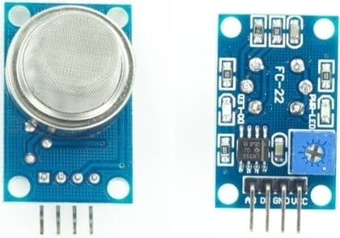](https://how2electronics.com/wp-content/uploads/2020/06/MQ5-Gas-Sensor.jpg)

Features:

* High sensitivity to LPG, Isobutene, Propane
* Small sensitivity to Alcohol, Smoke
* Detection range: 100-10000 ppm
* Fast response time: <10s

## 4.2. ESP-32

ESP32 is a series of low-cost, low-power system on a chip microcontroller with integrated Wi-Fi and dual-mode Bluetooth. To send emails with the ESP-32, we’ll use the ESP mail client library. This library allows the ESP32 to send and receive emails with or without attachments via SMTP and IMAP (Internet Message access protocol) servers.

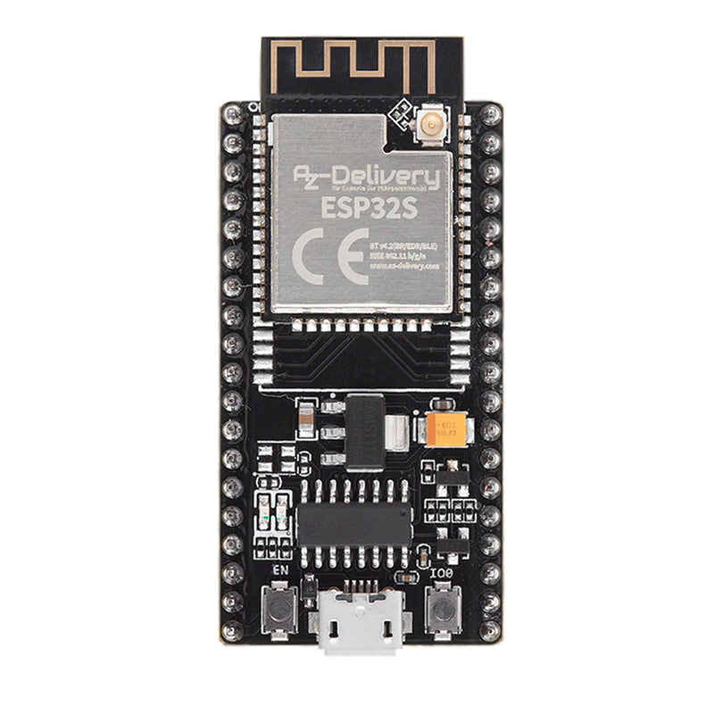

**Specification:**

* The ESP32 is dual core; this means it has 2 processors.
* It has Wi-Fi and Bluetooth built-in.
* The clock frequency can go up to 240MHz and it has a 512 kB RAM.
* This particular board has 30 or 36 pins, 15 in each row

## 4.3 LCD Display (16*2)

A 16x2 LCD means it can display 16 characters per line and there are 2 such lines. In this LCD each character is displayed in 5x7 pixel matrix. This LCD has two registers, namely, Command and Data. This is standard HD44780 controller LCD.

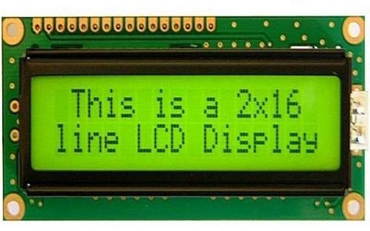

**Other Hardware**

* Buzzer
* Voltage Regulator (7805)
* Jumper wire
* TRANSITOR
* Lithium Polymer battery

## Software Requirement

### Thing speaks

Thing Speak enables sensors, instruments, and websites to send data to the cloud where it is stored in either a private or a public channel. Thing Speak stores data in private channels by default, but public channels can be used to share data with others.

### IFTTT

IFTTT allows you to do more with over 700 different apps and services, including Twitter, Drop box, Ever note, Fit bit, Amazon Alexa, and Google Assistant. We bring services together into Applets, automations that allow you to do things your apps and devices can't do on their own

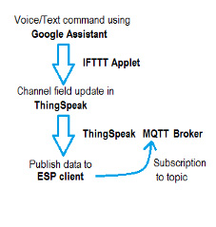

### Analysis application on Think speak

**Get Started with Thing Speak**

* Collect Data in a New Channel. Learn how to create a channel, collect data, and write the data to a new channel.
* Analyze Your Data. Learn how to analyze and visualize data using MATLAB.
* Act on Your Data. Set threshold limits on data to send a tweet under certain conditions.

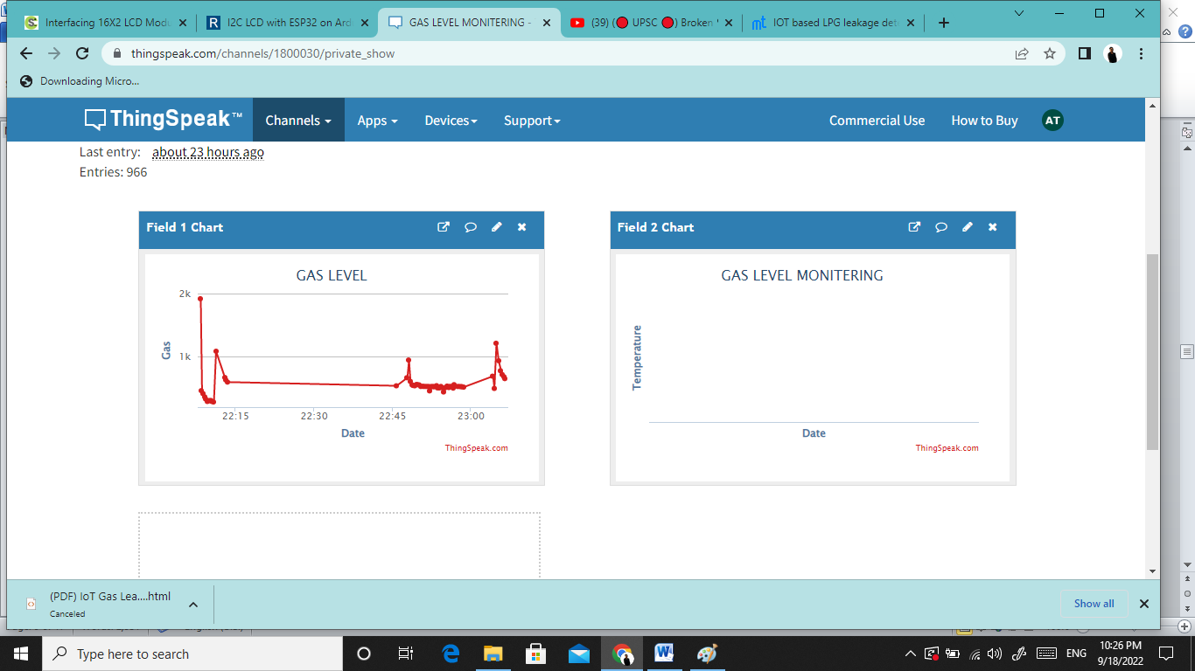

## EXPECTED OUTPUT

In gas leakage detection process, any gas leakage is checked by gas sensor (MQ_6) which is interfaced with ESP-32. When leakage is detected, motor will be immediately turn off the gas regulator-switch at same time it informs the user about the gas leakage by sending SMS, turning on the buzzer.

# COST ESTIMATION

|  |  |  |  |  |
| --- | --- | --- | --- | --- |
| **S. N** | **Hardware** | **Quantity** | **Rate** | **Amount** |
| 1 | ESP32 | 1 | RS.800 | RS.800 |
| 2 | Lithium Polymer battery | 1 | RS.100 | RS.100 |
| 3 | LCD 20*4 | 1 | RS.600 | Rs.600 |
| 4 | Jumper Wire(40pcs/pkt+Buzzer) | 1 | RS.200 | RS.200 |
| 5 | Male & Female Header (40 pin) | 2 | RS.100 | RS.200 |
| 6 | Glue stick | 1 | RS.50 | RS.50 |
| 7 | Adapter | 1 | RS.250 | RS.250 |
| **Total** | | | **2350** | |

# FEASIBILITY ANALYSIS

### Future Scope

* When there is a leakage in gas cylinder the main supply in home is automatically cut off by using home automation.
* Automatic payment should be paid by after cylinder booking from user bank account.

### 7.2 Advantage

* The main advantage is automatic booking of LPG cylinder by sending a SMS to the Distributor Company and also alerts the user.
* It ensures the security from the gas leakage and hazards.
* Itis very less time consuming and cylinder replaced in time.
* Easy to implement.

# CONCULSION

By implementing this project, we have minimized the risk of hazards of LPG gas leakage. We have implemented the automatic systems which ensure the safety of customer. Also, we have minimized the cylinder replacing time. Gas leakage leads to severe accidents resulting in material losses and human injuries. Gas leakage occurs mainly due to poor maintenance of equipment and inadequate awareness of the people. It is an economical system which can be installed in apartments, hotels LPG gas storage areas and wherever it is needed. The cost of the proposed system is lesser than the commercially available detectors in the market. It can help us to prevent from accidents in all directions Hence, LPG leakage detection is essential to prevent accidents and to save human lives. we discussed the methods used for identifying the leakages which can save many life. This method provides the user live data so the user can be aware any time.

### REFERENCES

[1]. Kumar Ketamine, Sabbani Hemanth, “Smart Gas Level Monitoring, Booking & Gas Leakage Detector over IoT”, 2017 IEEE 7th International advance Computing Conference

[2]. Saurabh Joshi, Rohit Patil, “Automatic System for LPG Refill Booking and Leakage Detection”, Vol-3 Issue-2 2017IJARIIE- ISSN (O)-2395-4396

[3].Ajay Kumar, Mukesh Kumar, Balwinder Singh, “Designing and Implementation of Smart LPG Trolley with Home Safety”, 2016 2nd International conference on Next Generation Computing Technologies (NGCT-2016) Dehradun

[4] MR. ARJITH BANK, MR. BODHAYAN AICH, MR. SUMAN GHOSH, “Microcontroller Based Low-Cost Gas Leakage Detector with SMS Alert”, Presented at the IEEE Conference, 2017.

[5]. LUAY FRAIWAN, KHALDON L WEESY, AYA BANI-SALMA, NOUR MANI, “A Wireless Home Safety Gas Leakage Detection System”, Presented at the IEEE Conference, 2011.

[6] .SHASHI KUMAR, PRANITA PADOLE, SHWETA SALVE, ADITYA SACHDEV, “Smart LPG Monitoring and Automatic Gas Booking System”, Presented at the IRJET Conference, 2018.

[7] R. NARESH NAIK, P. SIVA NAGENDRA REDDY, K. THARUN KUMAR REDDY, S. NANDA KISHORE, “Arduino Based LPG Gas Monitoring and Automatic Cylinder Booking with Alert System”, Presented at the IOSRJECE,2016.

[8] ABISHEK KUMAR SAHU, P BHASKAR, RAHUL KUMAR SHARMA, SK INZAMAM UL HAQUE, SUDHIR KUMAR, RICHA SHRIVASTAVA, “Gas Monitoring Using GSM”, Presented at the IJRASET,2017.

### APENDIX

